Realtime Log Viewer

1. Environment requirement and settings before use.
   1. VSWLogDynamic64A.dll 1.0.0.4 or newer.
   2. Enable in LogConfig.ini  
      [GLOBAL_PROPERTIES]   
      RealtimeLogPipeName=\\.\pipe\OUN_DRIVER
2. Launch Tools\RealtimeLog\RealtimeLogAgent.exe  
   you will see …  
   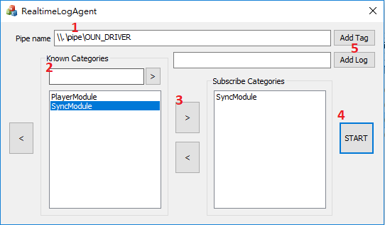
   1. Setup pipe name, you can use default.
   2. Add the category that you wish to filter to subscribe list.
   3. Add a known category to subscribe list
   4. Press START to begin receiveing.
   5. Press “Add Tag” and “Add Log” anytime that insert a string to the log file.